M.S. Ramaiah University of Applied Sciences – Faculty of Engineering & Technology (FET)
Portfolio Website

B. Tech. in AI/ML Engineering
Internship Work in
Department of Computer Science & Engineering



NAME: ANGEL BIJU
REG. NO. :25ETAI410016

Instructor: Ms. Pooja Sri R
(Ramaiah Academy)

JULY– 2026
Faculty of Engineering and Technology
M. S. Ramaiah University of applied sciences
Bengaluru -560 054

Faculty of Engineering and Technology


Certificate
This is to certify that the Internship Work titled “Portfolio”, done at Ramaiah Academy Foundation, is a Bonafide record of the work carried out by ANGEL BIJU, Reg. No. 25ETAI410016 in partial fulfilment of requirements for the award of B. Tech. Degree in AI/ML of M. S. Ramaiah University of Applied Sciences in the Department of Computer Science Engineering.
JULY – 2026

Ms.Pooja Sri Dr. T. N. Srikantha Dath
Associate Application Engineer Director
Ramaiah Academy Ramaiah Academy

Dr. C Narendra Babu
HOD, Department of Computer Science & Engineering

Declaration

The internship work is submitted in partial fulfilment of academic requirements for the B. Tech. Degree of M. S. Ramaiah University of Applied Sciences in the Department of Computer Science & Engineering. This internship work is a result of my own work and is in conformance to the guidelines as laid out in the University Student Handbook.
Sl. No. | Reg. No. | Student Name | Signature
1. | 25ETAI410016 | ANGEL BIJU

JULY 2026

Acknowledgements

I take this opportunity to express my sincere gratitude and appreciation to Ramaiah University of Applied Sciences, Bengaluru for providing me an opportunity to carry out my internship work.
It brings a sense of privilege to associate this work with Ramaiah Academy Foundation. Working under them has been a precious opportunity. I am immensely thankful for trainer’s Ms. Pooja Sri R for their constant encouragement, inspiring ideas and mentoring, which reflects in the final images of this work.
I am grateful to the University and thank Dr. C Narendra Babu, HOD of the Department of Computer Science & Engineering for providing me with this opportunity, guidance, and encouragement throughout.
I would like to earnestly thank Dr. Sarat Kumar Maharana, the Dean, FET, for and Dr. B S Dayananda, Associate Dean Academics, facilitating academic excellence in the college that helped in completing this project.
I would also like to earnestly thank Prof. Kuldeep Kumar Raina, the Vice Chancellor, for facilitating academic excellence in the college that helped in completing this project.
I am thankful to the management of Ramaiah University of Applied Sciences for providing all the facilities and resources for the successful completion of the course.
Finally, I thank my parents, friends and all my well-wishers who have supported me in this endeavor.
The values of dedication, discipline, work ethics and patience that I have imbibed here will always remain the guiding force throughout my life.

Abstract

Motivation: The motivation for the project was to create a professional digital identity while strengthening practical knowledge of frontend development. A portfolio provides a single platform to demonstrate technical abilities, completed projects, design skills, and continuous learning and as part of a resume.

Scope: The scope includes a responsive navigation bar, hero section, about section, skills section, project showcase, contact form, footer, theme switching and, interactive navigation. The implementation was developed incrementally by converting the existing static website into responsive webpage.

Methodology: The development process involved requirement identification, interface planning, component decomposition, React implementation, CSS styling, JavaScript-based interaction, responsive testing, debugging, and refinement. Vite was used as the React development and build environment.

Result: The completed implementation provides a responsive and visually consistent portfolio interface with React components such as Navbar, Hero, About, Skills, Projects, Contact, and Footer. Interactive features include a responsive navigation menu, dark/light theme support, dynamic greeting, project rendering, form validation, reusable button and color styles.

Conclusion: The project successfully demonstrates the practical application of modern frontend development concepts. It also provides a foundation for future enhancements such as backend-based contact handling, additional projects, improved accessibility, and deployment to a production hosting platform.

Table of Contents
Declaration ii
Acknowledgements iii
Abstract iv
1.Introduction 1
1.1 Background 1
1.2 Project Overview 1
1.3 Technologies Used 1
1.4 Objectives 1
2. Literature Review 3
2.1 Design Principles Applied 3
3. Problem Statement 4
3.1 Problem Definition 4
3.2 Challenges Identified 4
4. Problem Solving / Methodology 5
4.1 Development Approach 5
4.2 Component Architecture 5
4.3 Styling Strategy 5
4.4 Interactive Features 5
4.5 Testing and Debugging 6
5. Results and Discussions 7
5.1 Final Interface 7
5.2 Responsiveness 7
5.3 Visual Consistency 7
5.4 Functional Results 7
5.5 Limitations 7
6. Conclusions and Future Scope 8
6.1 Conclusion 8
6.2 Learning Outcomes 8
6.3 Future Scope 8
References 9
Appendix A: Project Structure 10
Code 1
HTML: 1
CSS: 3
Javascript: 7
FINAL PROJECT: 2
LINK 2
GitHub Repository 2
Screenshots: 2
Appendix B: Key Code Features 3
B.1 Shared Design Tokens 3
B.2 Contact Form 3

1.Introduction

1.1 Background
Personal portfolio websites have become an important medium for students and developers to present their technical abilities, projects, interests, and professional identity. Unlike a conventional resume, an interactive portfolio can demonstrate practical work through live interfaces, project descriptions, source-code links, and responsive design, demonstrating the person’s knowledge of it.

1.2 Project Overview
The project is a responsive personal portfolio website developed for Angel Biju (myself). The interface presents an introduction in the hero section, an About section, technical skills, projects, a contact form, and social links. The webpage supports light/dark theme presentation.

1.3 Technologies Used
HTML – semantic structure and content organization in the original implementation.
CSS – responsive layouts, animations, component styling, hover effects, and theme styling.
JavaScript – dynamic greeting, theme switching, navigation interactions, validation, and project rendering.
Visual Studio Code – source-code editing and project development environment.
React – component-based implementation of the final portfolio interface.
Vite – development server and build tooling for the React application.
Git/GitHub – suitable version-control and source-code hosting workflow for the project.
Netlify – intended production deployment platform for the completed frontend application.

1.4 Objectives
- Develop a professional and responsive personal portfolio website.
- Convert a static HTML/CSS/JavaScript portfolio into a modifiable React application.
- Understand working of frontend architecture.
- Implement responsive navigation and mobile-friendly layouts.
- Implement light/dark theme switching.
- Present projects and technical skills clearly.
- Implement client-side contact form validation.
- Prepare the project for production deployment.

2. Literature Review

The development of a modern portfolio draws on established practices in responsive web design, component-based user-interface development, accessibility, and frontend performance. Responsive design principles emphasize flexible layouts that adapt to different screen sizes rather than maintaining a fixed desktop-only presentation.
Component-based frameworks such as React encourage developers to divide an interface into independent, reusable units. This approach is particularly suitable for portfolios because sections such as navigation, project cards, skills, contact forms, and footers can be maintained independently while sharing common styles.
Modern frontend tooling also emphasizes fast development feedback and optimized production builds. Vite provides a lightweight development environment and build process suitable for React applications. Consistent design tokens, reusable button classes, responsive breakpoints, semantic HTML, and accessible labels further improve maintainability and usability.

2.1 Design Principles Applied
Visual hierarchy through typography, spacing, contrast, and section headings.
Consistent primary and accent colours across buttons and interactive elements.
Responsive grid and flex layouts for desktop and mobile devices.
Clear navigation between major sections.

3. Problem Statement

Students and beginner developers often have difficulty presenting their technical learning and projects in a structured, professional, and visually appealing manner. A basic static web page can display information, but repeated markup becomes difficult to maintain as the portfolio grows. In addition, inconsistent styling and limited responsiveness can reduce the quality of the user experience.

3.1 Problem Definition
The problem addressed by this project is to design and implement a responsive, maintainable, and interactive personal portfolio that communicates the developer’s skills and projects effectively while providing a foundation for future full-stack functionality.

3.2 Challenges Identified
Converting a static HTML structure into reusable React components.
Maintaining consistent styling across independent component CSS files.
Creating a navigation system that behaves differently on desktop and mobile screens.
Implementing light/dark theme switching without duplicating large amounts of CSS.
Validating contact-form input on the client side.
Keeping images and layouts visually balanced at different screen sizes.

4. Problem Solving / Methodology

4.1 Development Approach
The project was developed in increments. The existing HTML, CSS, and JavaScript implementation was first reviewed. The interface was then reused into React components, with each component responsible for a specific section of the portfolio.

4.2 Component Architecture
Navbar.jsx – responsive navigation and theme/menu controls.
Hero.jsx – introduction, profile image, greeting.
About.jsx – professional introduction and key areas of interest.
Skills.jsx – technical skills displayed.
Projects.jsx – project cards generated from project data using map().
Contact.jsx – contact form and client-side validation.
Footer.jsx – copyright information and social/contact links.

4.3 Styling Strategy
Each major component has its own CSS file for section-specific layout and appearance. Shared visual rules are centralized in a global stylesheet. CSS variables such as --primary and --accent are used to maintain a consistent colour palette majorly in the details of the buttons.

4.4 Interactive Features
Dynamic greeting based on the current time of day.
Light/dark theme toggle with ‘localStorage’ persistence.
Responsive mobile navigation controlled by a menu button.
Navigation menu closes after a mobile navigation link is selected.
Client-side validation for name, email, and message fields.
Dynamic copyright year in the footer.

4.5 Testing and Debugging
Testing focused on navigation behaviour, responsive layouts, button interactions, theme switching, image presentation, and contact-form validation. During debugging, attention was given to selector naming, class-name consistency, and JavaScript event handling. The React implementation also reduces repeated markup and makes future changes easier to isolate.

5. Results and Discussions

5.1 Final Interface
The final portfolio is organized into distinct sections with a clear visual hierarchy, each accessible from the Hero section. Each section serves its own purpose. The navigation bar is visible/stuck at the top the screen even when scrolled.

5.2 Responsiveness
The interface uses flexible grid and flexbox layouts with responsive breakpoints. On smaller screens, the navigation changes to a menu-based layout, hero content stacks vertically, project and skill cards adapt to available width, and contact controls remain readable.

5.3 Visual Consistency
A consistent visual system is maintained using a dark blue primary colour, orange accent colour, light background, and consistent button styling.

5.4 Functional Results
Navigation links connect to the relevant portfolio sections.
The hero section presents a dynamic greeting based on the time of the day.
The profile image is displayed in the hero section.
The About section presents professional information.
The theme toggle changes the visual presentation between light and dark and remembers the selected theme.

5.5 Limitations
The current contact form performs client-side validation but does not yet transmit submissions to a backend or email service.
The portfolio currently focuses primarily on frontend functionality.

6. Conclusions and Future Scope

6.1 Conclusion
The Portfolio Website project successfully demonstrates the transition from a static web interface to a structured React application. The implementation combines responsive CSS, JavaScript interactions, reusable React components, dynamic data rendering, theme switching, and client-side form validation. The project provided practical experience in organizing frontend code and applying modern web-development practices.

6.2 Learning Outcomes
Understanding React component structure and JSX.
Using props and arrays to support reusable interface elements.
Using map () to render dynamic content.
Separating component-specific CSS from shared global styles.
Understanding responsive web design using Flexbox, Grid, and media queries.
Implementing browser-side state such as theme preferences with localStorage.
Debugging JavaScript and UI behaviour using browser developer tools.
Preparing a Vite-based application for production deployment.

6.3 Future Scope
Connect the contact form to Emails, Netlify Forms, or a custom Node.js/Express backend.
Add a dedicated backend and database for storing contact submissions.
Add project filtering, project detail pages, and real GitHub/live-demo links.
Add downloadable resume/CV functionality.
Improve accessibility with keyboard navigation, ARIA refinement, and automated audits.
Add animations using a lightweight animation library where appropriate.
Add analytics to understand portfolio visitor behaviour while respecting privacy.
Deploy the final React/Vite build on Netlify and configure a custom domain if required.

References

React Documentation – React concepts, components, JSX, and rendering: https://react.dev/
Vite Documentation – Vite development and production build tooling: https://vite.dev/
Netlify Documentation – deployment and hosting guidance for frontend applications: https://docs.netlify.com/2

Appendix A: Project Structure

The structure hierarchy of the some main components of the program as in the Vite react folder is as follows:

Each section of the website is coded in separate files, hence this helps to debug if any issues occur, or make changes to particular sections without affecting the code for rest of the wepage.

Public folder contains files that can be referenced in the any file in the parent folder.

Code

HTML:
<!DOCTYPE html>
<html lang="en">
<head>
<meta charset="UTF-8">
<meta name="viewport" content="width=device-width, initial-scale=1.0">
<title>My Portfolio[Angel Biju]</title>

<meta name="description" content="Full-stack web developer specializing
in React and Node.js. Available for freelance projects.">
<meta name="keywords" content="web developer, React, JavaScript, portfolio">
<meta name="author" content="Doppleganger">

<!-- Open Graph (for Facebook, LinkedIn, WhatsApp previews) -->
<meta property="og:title" content=" Doppleganger | Web Developer">
<meta property="og:description" content="Check out my portfolio and projects!">
<meta property="og:image" content="https://johndoe.com/preview.jpg">
<meta property="og:url" content="https://johndoe.com">
<meta property="og:type" content="website">

<!-- Twitter Card -->
<meta name="twitter:card" content="summary_large_image">
<meta name="twitter:title" content=" Doppleganger | Web Developer">
<meta name="twitter:description" content="Check out my portfolio!">
<link rel="icon" href="Profile.jpg">
<link rel="stylesheet" href="style.css">
</head>
<body>

<header class="site-header">
<nav class="navbar">
<div class="logo">AEB</div>
<ul class="nav-link">
<li><a href="#about">About</a></li>
<li><a href="#skills">Abilities</a></li>
<li><a href="#projects">Projects</a></li>
<li><a href="#contact">Contact</a></li>
</ul>
<button class="theme-toggle" aria-label="Toggle dark mode" title="Toggle dark mode">🌙</button>
<button class="menu-toggle" aria-label="Toggle navigation" aria-expanded="false">≡</button>
</nav>
</header>
<main>
<section class="hero-section" id="hero">
<h1>Hi I'm <span class="highlight"> Angel😊👀</span></h1>
<p class="tagline">I'm a passionate web developer based in Mysuru. Also a novice to cybersecurity.</p>
<div class="hero-button">
<a href="#projects" class="btn btn-primary">View My Work</a>
<a href="#contact" class="btn btn-secondary">Contact Me</a>
</div>
</section>
<section id="About" class="about-section">
<h2>About Me</h2>
<figure class="profile-figure">
<img src="Profile.jpg" alt="Profile Picture">
<figcaption>Angel - developer in the making</figcaption>
</figure>
<p>I love building programs, moreover using my analytical skills to find better and simpler ways to connect elements</p>
</section>
<section id="skills" class="skill-section">
<h2>My Skills</h2>
<div class="skill-grid">
<div class="skill-item" data-level="90">HTML</div>
<div class="skill-item" data-level="80">CSS</div>
<div class="skill-item" data-level="70">Javascript</div>
<div class="skill-item" data-level="85">React</div>

</div>
</section>
<section id="Projects" class="project-section">
<h2>My Project</h2>
<div class="project-grid">
<article class="project-card" data-category="web">
<img src="weather.png" alt="Weather app Screenshot" width="350px">
<h3>Weather App</h3>
<p>Real-time weather dashboard using OpenWeather API</p>
<div class="project-tags">
<span class="tag">React</span>
<span class="tag">API</span>
</div>
<a href="#">Live Demo</a>
<a href="#">GitHub</a>
</article>
<article class="project-card" data-category="web">
<img src="weather.png" alt="Weather app Screenshot" width="350px">
<h3>Weather App</h3>
<p>Real-time weather dashboard using OpenWeather API</p>
<div class="project-tags">
<span class="tag">React</span>
<span class="tag">API</span>
</div>
<a href="#">Live Demo</a>
<a href="#">GitHub</a>
</article>
<article class="project-card" data-category="web">
<img src="weather.png" alt="Weather app Screenshot" width="350px">
<h3>Weather App</h3>
<p>Real-time weather dashboard using OpenWeather API</p>
<div class="project-tags">
<span class="tag">React</span>
<span class="tag">API</span>
</div>
<a href="#">Live Demo</a>
<a href="#">GitHub</a>
</article>
</div>
</section>
<section id="contact" class="contact-section">
<h2>Get in Touch</h2>
<form id="contact-form" action="#" method="post" novalidate>
<div class="form-group">
<label for="name">Name</label>
<input type="text" id="name" name="name" placeholder="Enter your name" required>
</div>
<div class="form-group">
<label for="email">Email</label>
<input type="email" id="email" name="email" placeholder="Enter your email" required>
</div>
<div class="form-group">
<label for="message">Message</label>
<textarea name="message" id="message" placeholder="Enter message" required></textarea>
</div>
<button type="submit" class="btn btn-primary">Send Message</button>
</form>
</section>
</main>

<footer class="site-footer">
<p>&copy; <span class="footer-year"></span>Angel Biju. Built with HTML & CSS </p>
<nav aria-label="socialmedia links">
<a href="mailto:angelbiju2327@gmail.com">Email</a>
<a href="https://github.com/anglemichael" target="_blank">Github</a>
<a href="https://linkedin.com/in/angel-biju-aa17b8386" target="_blank">Linkedin</a>
</nav>
</footer>
<script src="script.js"></script>
</body>
</html>

CSS:
*{
box-sizing: border-box;
margin:0;
padding: 0;
}
:root{
--primary:#1B4F72;
--accent:#F18F01;
--text:#2C3E50;
--light:#F4F6F8;
--white:#FFFFFF;
--font-main:'Segoe UI', Tahoma, Geneva, Verdana, sans-serif;
}
body{
font-family:var(--font-main);
color:var(--text);
line-height:1.6;
background: #FFFFFF;
}
header{
position:sticky;
top:0;
z-index: 1000;
}
.navbar{
display: flex;
justify-content: space-between;
align-items: center;
padding: 20px 5%;
background:var(--primary);
}
.logo{
font-size: 28px;
font-weight:bold;
color:var(--white);
}
.profile-figure img{
width:180px;
height:180px;
border-radius:50%;
}
.nav-link{
list-style:none;
display: flex;
gap:30px;
}
.nav-link a{
text-decoration: none;
color:var(--white);
font-weight:500;
}
.nav-link a:hover{
color:var(--accent);
}
.hero-section{
background:linear-gradient(135deg, var(--primary),#2E86AB);
color: #F4F6F8;
text-align: center;
}
.hero-section h1{
font-size: 45px;
margin-bottom:20px;
}
.skill-grid{
display: grid;
grid-template-columns: repeat(auto-fill,minmax(200px,1fr));
gap: 20px;
margin-top: 40px;
text-align: center;
}
.skill-item{
background-color: var(--light);
border: 2px solid var(--primary);
border-radius: 12px;
padding: 30px 20px;
text-align: center ;
font-weight: bold ;
font-size: 1.1rem;
transition: transform 0.3s,box-shadow 0.3s;
}
.skill-item:hover{
transform: translatey(-5px);
box-shadow: 0 10px 30px rgba(0, 0, 0, 0.47);
}
.project-grid{
display: grid;
grid-template-columns: repeat(auto-fill,minmax(300px,1fr));
gap: 30px;
margin-top: 20px;
text-align: center;
}
.project-card{
background-color: var(--primary);
padding: 12px;
border-radius: 16px;
color: white;
overflow: hidden;
text-align: center;
transition: transform 0.3s, box-shadow 0.3s;
}
.project-card:hover{
transform: translateY(-5px);
box-shadow: 0 10px 30px rgba(0, 0, 0, 0.818);
}
.project-card img{
width: 100%;
height: 200px;
object-fit: cover;
}
.project-card a{
text-decoration: none;
color: var(--white);
}
.btn {
display: inline-block;
padding: 12px 28px;
border-radius: 8px;
text-decoration: none;
font-weight: 600px;
cursor: pointer;
border: 2px solid transparent;
background-color: var(--accent);
color: var(--white);
}
.btn:hover{
background-color: transparent;
color: var(--accent);
border-color: var(--accent);
}
.btn-primary{
background-color: var(--accent);
color: var(--white);
}
.btn-primary:hover{
background-color: transparent;
color: var(--accent);
border-color: var(--accent);
}
section{
padding: 50px 5%;
}
section h2{
font-size: 2.2rem;
text-align: center;
margin-top: 50px;
position: relative;
}

section h2::after{
content: "";
display: block;
width: 60px;
height: 4px;
background: var(--accent);
margin: 12px auto 0;
border-radius: 2px;
}
@keyframes fadeinup{
from{opacity: 0; transform: translateY(30px);}
to{opacity: 1;transform: translateY(0);}
}
.tagline{
animation: fadeinup 0.8s ease 0.2s both;
}
.hero-button{
animation: fadeinup 0.8s ease 0.2s both;
}
.hero-section h1{
animation: fadeinup 0.8s ease 0.2s both;
}
.contact-section{
max-width: 600px;
margin: 0 auto;
text-align: center;
}
.form-group{
margin-bottom: 24px;
}
.form-group label{
display: block;
font-weight: 600;
margin-bottom: 8px;
color: var(--primary);
}
.form-group input,.form-group textarea{
width: 100%;
padding: 14px 16px;
border: 2px solid #ddd;
border-radius: 8px;
font-size: 1rem;
font-family: inherit;
transition: border-color 0.3s;
}
.form-group input:focus,.form-group textarea:focus{
outline: none;
border-color: var(--primary);
box-shadow: 0 0 0 3px rgba(27,79,114,0.15);
}
.site-footer{
background-color: var(--primary);
color: rgba(255, 255, 255, 0.8);
text-align: center;
padding: 40px 5%;
}
.site-footer a{
text-decoration: none;
color: rgba(255, 255, 255, 0.8);
}
.menu-toggle{
display: none;
background: none;
border: none;
color: var(--white);
font-size: 30px;
cursor: pointer;
}
@media (max-width:768px){
.menu-toggle{
display: block;}
.nav-link{
display:none;
position:absolute;
top:70px;
left:0;
width:100%;
background:#1B4F72;
flex-direction:column;
text-align:center;
padding:20px 0;
gap:20px;
}
.nav-link.open{
display:flex;
}
}

.about-section{
justify-content: center;
}

body,
.site-header,
.hero-section,
.skill-item,
.project-card,
.contact-section,
.site-footer,
input,textarea,
.btn,
a{
transition: all 0.3s ease;
}
body[data-theme="dark"]{
background-color: black;
color: white;
}
body[data-theme="dark"].site-header,
body[data-theme="dark"].navbar{
background-color: #1a1a1a;
}
body[data-theme="dark"].nav-link a{
color: white;
}
body[data-theme="dark"].nav-link a:hover,
body[data-theme="dark"].nav-link a:active{
color: #F18F01;
}
body[data-theme="dark"].logo{
color: white;
}
body[data-theme="dark"].hero-section{
background: linear-gradient(135deg #111827, #1f2937);
}
body[data-theme="dark"].highlight{
color: orange;
}
body[data-theme="dark"].highlight{
color:orange;
}

body[data-theme="dark"] .about-section {
background: #121212;
color: #f5f5f5;
}
body[data-theme="dark"] .skill-section {
background: #181818;
}

body[data-theme="dark"] .skill-item {
background: #242424;
color: #ffffff;
border-color: #F18F01;
}

body[data-theme="dark"] .projects-section {
background: #121212;
}

body[data-theme="dark"] .project-card {
background: #242424;
color: #ffffff;
box-shadow: 0 5px 20px rgba(255,255,255,0.08);
}

body[data-theme="dark"] .project-card h3,
body[data-theme="dark"] .project-card p {
color: #ffffff;
}

body[data-theme="dark"] .tag {
background: #F18F01;
color: #ffffff;
}

body[data-theme="dark"] .contact-section {
background: #181818;
}

body[data-theme="dark"] input,
body[data-theme="dark"] textarea {
background: #2b2b2b;
color: #ffffff;
border: 1px solid #555;
}

body[data-theme="dark"] input::placeholder,
body[data-theme="dark"] textarea::placeholder {
color: #bdbdbd;
}

body[data-theme="dark"] label {
color: #ffffff;
}

body[data-theme="dark"] .btn-primary {
background: #F18F01;
color: #ffffff;
}

body[data-theme="dark"] .btn-secondary {
background: #F18F01;
color: #ffffff;
}

body[data-theme="dark"] .btn-secondary:hover {
background: #ffffff;
color: #121212;
}
body[data-theme="dark"] .btn-primary:hover {
background: #ffffff;
color: #121212;
}

body[data-theme="dark"] .site-footer {
background: #1a1a1a;
color: #cccccc;
}

body[data-theme="dark"] .site-footer a {
color: #ffffff;
}

body[data-theme="dark"] .site-footer a:hover {
color: #F18F01;
}

body[data-theme="dark"] .theme-toggle {
background: #333333;
color: #ffffff;
border: 1px solid #666666;
}

Javascript:

console.log("Javascript is connected")
const year= new Date().getFullYear();
document.querySelector('.site-footer p').innerHTML=
`&copy; ${year} Angel Biju. All rights reserved.`;

function getGreeting(){
const hour= new Date().getHours();
if(hour < 12) return "Good Morning";
if (hour<17) return "Good Afternoon";
return "Good Evening";
}
const heroTitle =document.querySelector('.hero-section h1');
if (heroTitle){
heroTitle.textContent = `${getGreeting()}, I'm Angel 👋`;
}

//Dark Mode

let themeBtn = document.querySelector(".theme-toggle");
function updateThemeIcon(theme) {
themeBtn.textContent = theme === "dark" ? "🌙" : "☀️";
}
if (themeBtn) {
let savedTheme = localStorage.getItem("theme") || "light";
document.body.dataset.theme = savedTheme;
updateThemeIcon(savedTheme);
themeBtn.addEventListener("click", () => {
let nextTheme =
document.body.dataset.theme === "light"? "dark": "light";
document.body.dataset.theme = nextTheme;
localStorage.setItem("theme", nextTheme);
updateThemeIcon(nextTheme);
});
}

let menuToggle = document.querySelector(".menu-toggle");
let navLinks = document.querySelector(".nav-link");

if (menuToggle && navLinks) {
menuToggle.addEventListener('click',()=>{
navLinks.classList.toggle("open");
menuToggle.setAttribute('aria-expanded',navLinks.classList.contains('open'));
})
document.querySelectorAll(".nav-link a").forEach(link => {
link.addEventListener("click", () => {
navLinks.classList.remove("open");
menuToggle.setAttribute("aria-expanded", "false");
});
});
window.addEventListener("resize", () => {
if (window.innerWidth > 768) {
navLinks.classList.remove("open");
menuToggle.setAttribute("aria-expanded", "false");
}
});
}

let header = document.querySelector(".site-header");

window.addEventListener("scroll", () => {
if (window.scrollY > 50) {
header.classList.add("scrolled");
} else {
header.classList.remove("scrolled");
}
});

let sections = document.querySelectorAll("section[id]");
let navItems = document.querySelectorAll(".nav-link a");

window.addEventListener("scroll", () => {
let current = "";
sections.forEach(section => {
if (window.scrollY >= section.offsetTop - 100) {
current = section.id;
}
});
navitems.forEach(link=>{
link.classList.remover("active");
if(link.getAttribute("href")===`#${current}`){
link.classList.add("active");
}
});
});

let footyear=document.querySelector(".footer-year");
if(footyear){
footyear.textContent=new Date().getFullYear();
}

//project filter

let projects=[{id:1, name:"Weather App", category:"web", tech:["React", "API"]},
{id:2, name:"Todo App",category:"web",tech:["Javascript"]},
{id:3, name:"Portfolio", category:"design",tech:["HTML,CSS"]},
{id:4, name:"Calculator",category:"web",tech:["Javascript"]}]

function renderProjects(filter="all"){
let grid=document.querySelector(".project-grid");
let filtered=filter==="all"?projects:projects.filter(p=>p.category===filter);
grid.innerHTML=filtered.map(project=>`
<article class="project-card">
<div class="project-card-body">
<h3>${project.name}</h3>
<div class="project-tags">${project.tech.map(t=>`<span class="tag1">${t}</span>`).join("")}</div>
<a href="#" class="btn btn-primary">View Project</a>
</div>
</article>
`).join("");
}

//filter button

document.querySelectorAll(".filter.btn").forEach(btn=>{
btn.addEventListener('click',()=>{
document.querySelectorAll(".filter.btn").forEach(b=>b.classList.remove('active'));
btn.classList.add("active");
renderProjects(btn.dataset.filter);
});
});

renderProjects();

let form=document.querySelector("#contact-form");
function showError(input,message){
let group=input.closest('.form-group');
let existing=group.querySelector(".error-msg");
if(!existing){
let errEL=document.createElement('span');
errEL.className="error-msg";
errEL.textContent=message;
group.appendChild(errEL);
}
input.classList.add("error")
}
function clearErrors(){
document.querySelectorAll(".error-msg").forEach(e=>e.remove());
document.querySelectorAll(".error").forEach(e=>e.classList.remove('error'));
}
form.addEventListener("submit",async(e)=>{
e.preventDefault();
clearErrors();
let name=form.querySelector("#name");
let email=form.querySelector("#email")
let message=form.querySelector("#message")
let valid=true;
if(!name.value.trim()){
showError(name,"Name is required")
valid=false;
}
if(!email.value.includes("@")){
showError(email,"Enter a valid email");
valid=false
}
if(message.value.trim().length<10){
showError(message,"Message must be at least 10 characters")
valid=false;
}
if(valid){
let btn=form.querySelector('button[type="submit"]');
btn.textContent="sending...";
btn.disabled=true;
await new Promise(resolve=>setTimeout(resolve,1500));
btn.textContent="✅ Message Sent";
// alert("Thank you! Your message has been sent.");
form.reset();
setTimeout(()=>{
btn.textContent="Send Message";
btn.disabled=false
},3000);
}
});

FINAL PROJECT:
LINK: https://steady-babka-b39c10.netlify.app/
GitHub Repository: https://github.com/anglemichael/portfolio/

Screenshots:
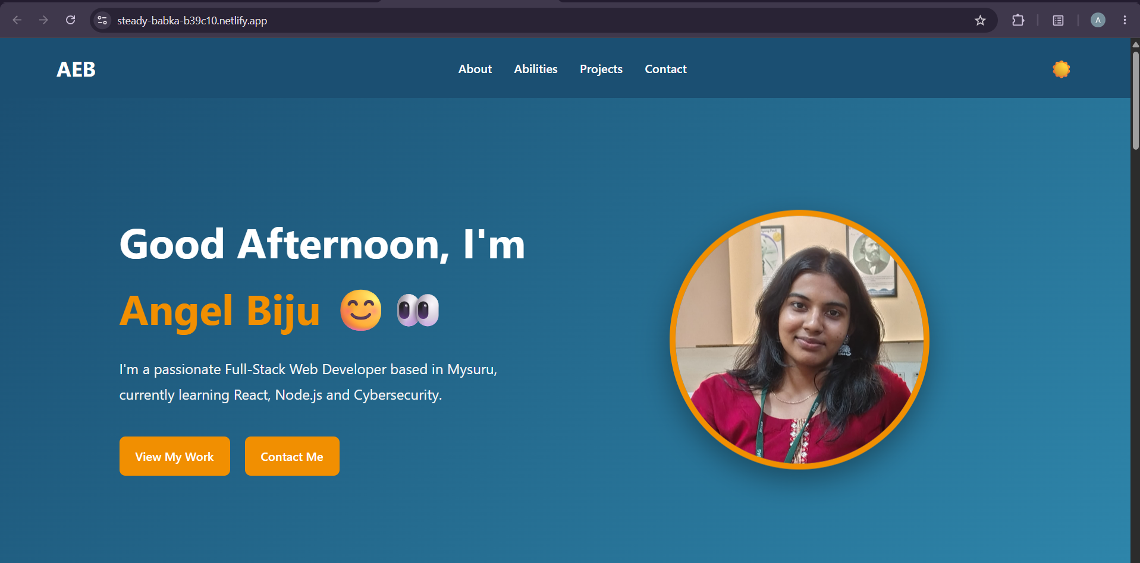

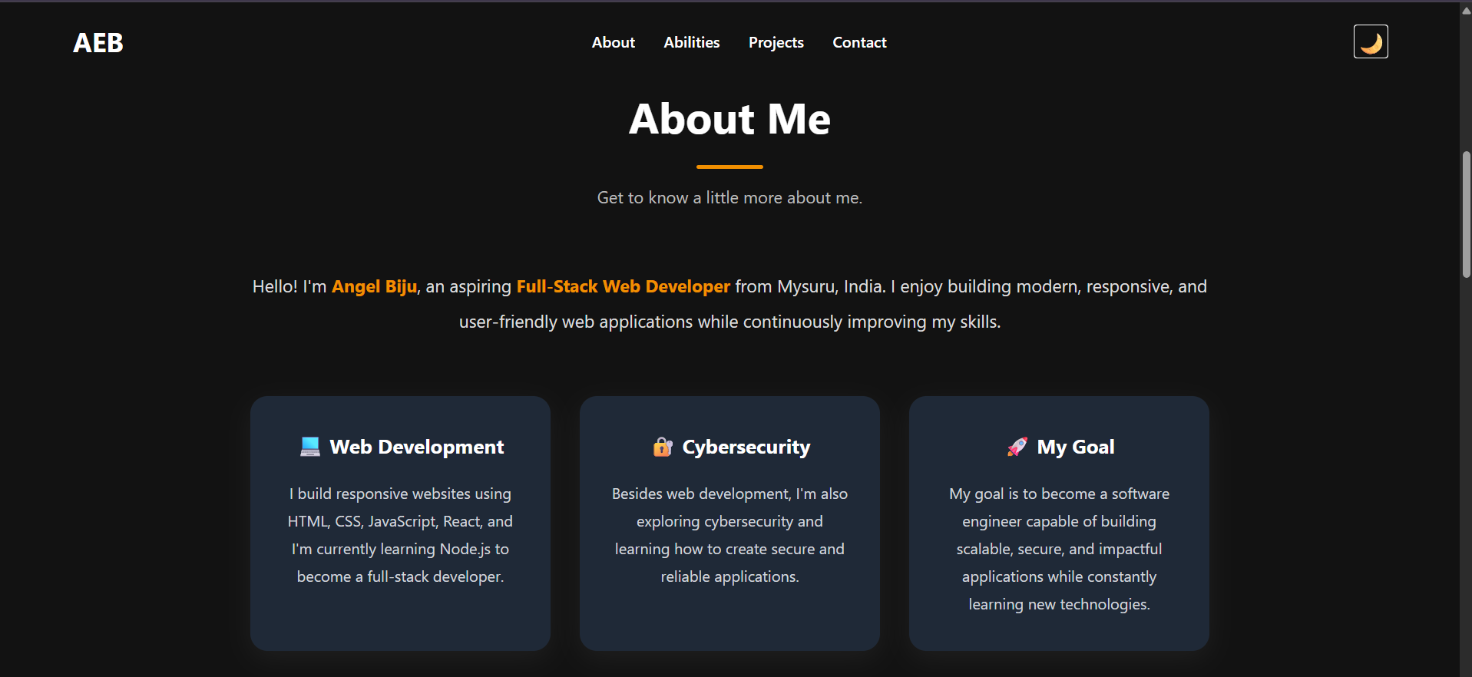

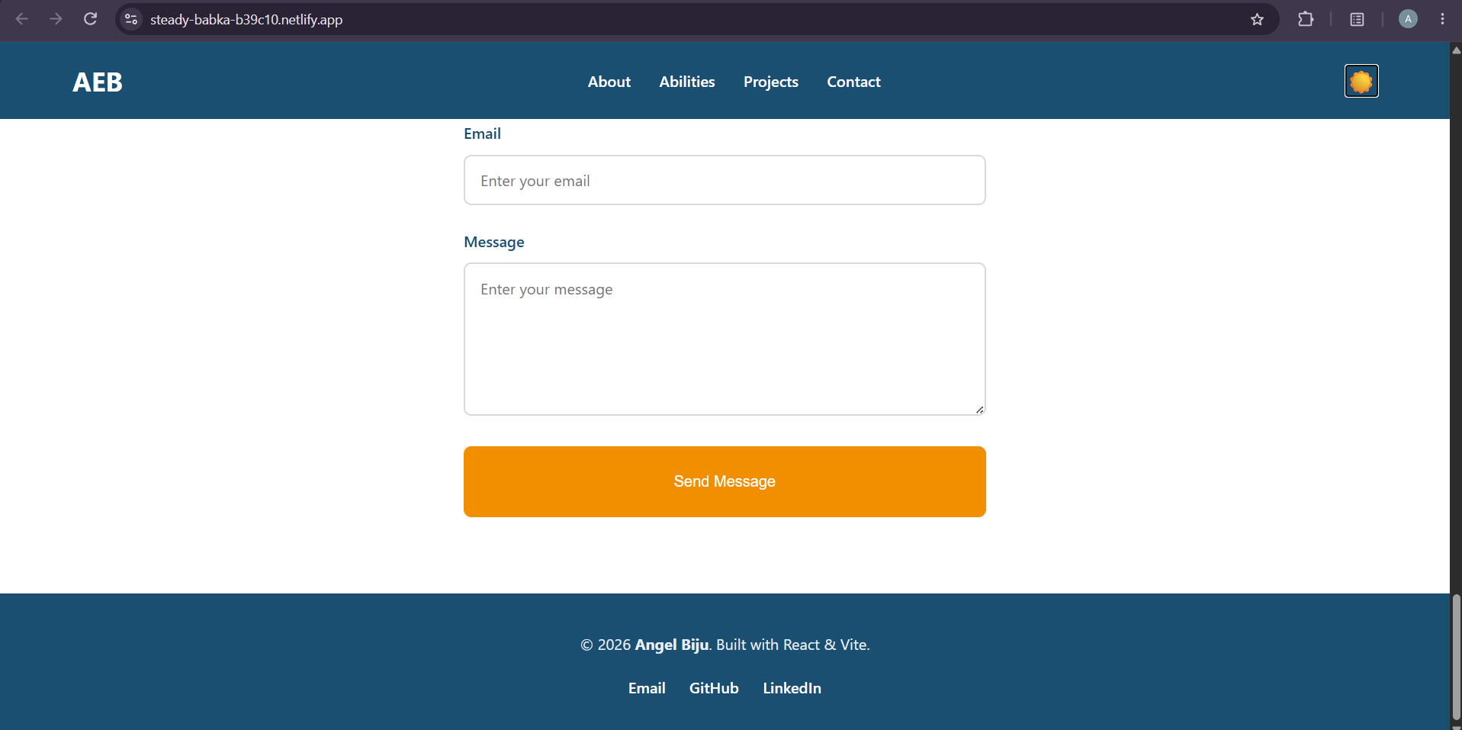

Appendix B: Key Code Features

B.1 Shared Design Tokens
The public stylesheet defines common colours and button styles. For example, the primary blue and orange accent are stored as CSS custom properties and reused throughout the portfolio.
Any image or file in the public file can be linked through in any of the files.

B.2 Contact Form
The current contact form validates required fields and checks for a basic email format and a minimum message length. At present, successful validation produces interface feedback only; a backend service is required for actual message delivery and storage.

